Web application design

1. <Nurse> Register examming design

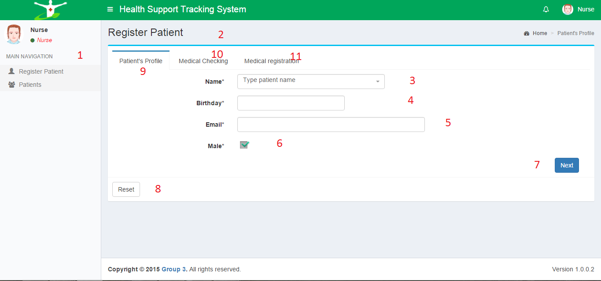

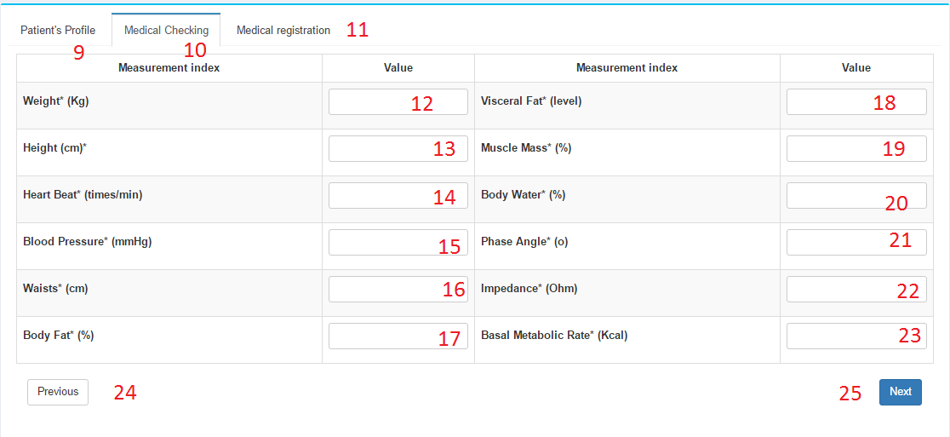

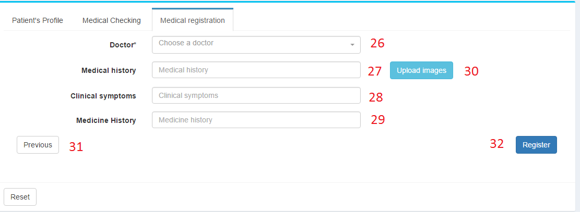

**Fields**

|  |  |  |  |  |  |  |  |
| --- | --- | --- | --- | --- | --- | --- | --- |
| No | Field Name | Description | Read Only | Mandatory | Control Type | Data Type | Length |
| 1 | Navigation bar | Navigation bar | Yes | No | N/A | N/A | N/A |
| 2 | Title bar | Title bar | Yes | No | N/A | N/A | N/A |
| 3 | txtPatientName | Patient’s full name | No | Yes | Textbox | String | 50 |
| 4 | txtBirthday | Patient’s birthday | No | Yes | Textbox | String | 50 |
| 5 | txtEmail | Patient’s email | No | Yes | Textbox | String | 50 |
| 6 | cbGender | Patient’s gender | No | No | Checkbox | Byte | 1 |
| 12 | txtWeight | Patient’s weight | No | Yes | Textbox | Integer | 3 |
| 13 | txtHeight | Patient‘s height | No | Yes | Textbox | Integer | 3 |
| 14 | txtHeartBeat | Patient’s heart beat | No | Yes | Textbox | Integer | 3 |
| 15 | txtBloodPressure | Patient’s blood pressure | No | Yes | Textbox | Integer | 3 |
| 16 | txtWaists | Patient’s waits | No | Yes | Textbox | Integer | 3 |
| 17 | txtBodyFat | Patient’s body fat | No | Yes | Textbox | Float | 3 |
| 18 | txtVisceralFat | Patient’s visceral fat | No | Yes | Textbox | Float | 3 |
| 19 | txtMuscleMass | Patient’s muscle mass | No | Yes | Textbox | Float | 3 |
| 20 | txtBodyWater | Patient’s body water | No | Yes | Textbox | Float | 3 |
| 21 | txtPhaseAngle | Patient’s phase angle | No | Yes | Textbox | Float | 2 |
| 22 | txtImpedance | Patient’s impedance | No | Yes | Textbox | Float | 4 |
| 23 | txtBasalMetabolicRate | Patient’s basal metabolic rate | No | Yes | Textbox | Float | 4 |
| 26 | optDoctor | Doctor will be assigned | No | Yes | Select box | Integer | 4 |
| 27 | txtMedicalHistory | Patient’s medical history | No | No | Textbox | String | 1000 |
| 28 | txtSymptoms | Patient’s current symptoms | No | Yes | Textbox | String | 1000 |
| 29 | txtMedicineHistory | Patient’s medicine use history | No | No | Textbox | String | 1000 |

**Buttons/Hyperlinks**

|  |  |  |  |  |
| --- | --- | --- | --- | --- |
| No | Function | Description | Validation | Outcome |
| 7 | btnNext | Next button | Validate all fields in current tab | Go to next tab (Medical Checking) |
| 8 | btnReset | Reset button | N/A | Reset all fields |
| 9 | btnTab1 | Tab Patient’s Profile | N/A | Go to tab Patient’s Profile |
| 10 | btnTab2 | Tab Medical Checking | N/A | Go to tab Medical Checking |
| 11 | btnTab3 | Tab Medical Registration | N/A | Go to tab Medical Registration |
| 24 | btnPrevious | Previous button | N/A | Go to previous tab (Patient’s Profile) |
| 25 | btnNext2 | Next button | Validate all fields in current tab | Go to next tab (Medical Registration) |
| 30 | btnUploadImage | Upload medical image | N/A | Open Upload medical history image pop-up |
| 31 | btnPrevious2 | Previous button | N/A | Go to previous tab (Medical Checking) |
| 32 | btnRegister | Register examming | Validate all input fields before submitting | Submit registration |

1. <Nurse> Register examming with old patient

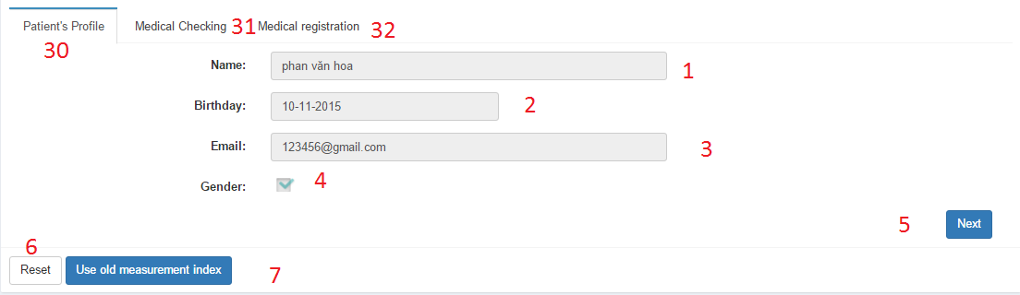

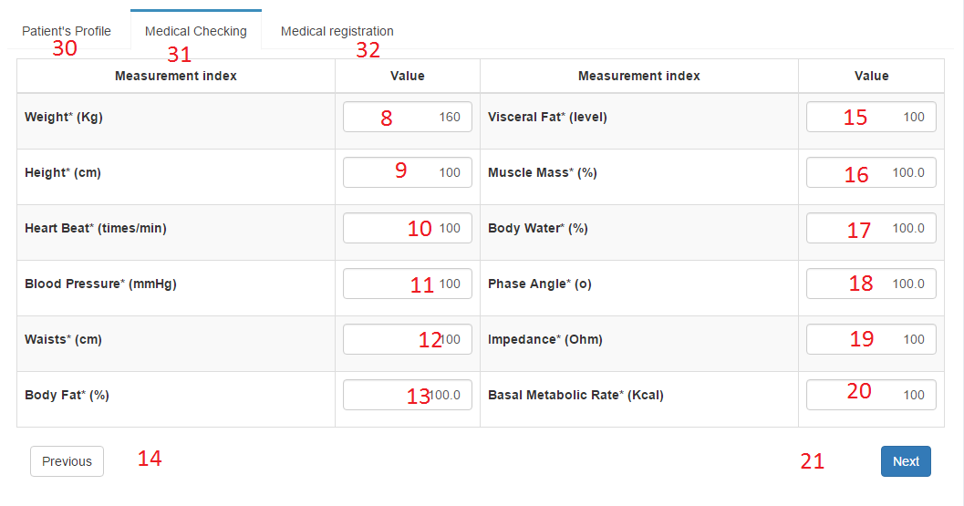

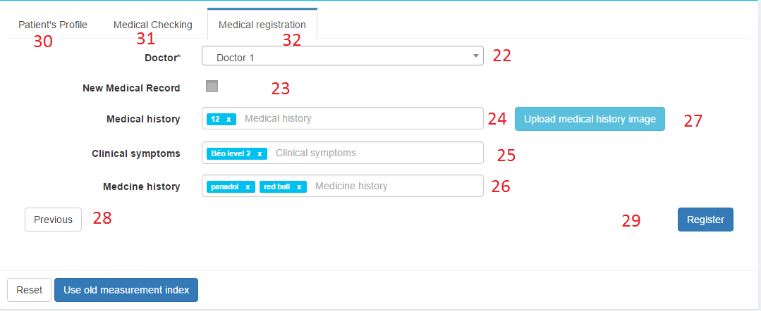

Fields

|  |  |  |  |  |  |  |  |  |  |  |  |
| --- | --- | --- | --- | --- | --- | --- | --- | --- | --- | --- | --- |
| No | Field Name | | | Description | Read Only | Mandatory | | Control Type | Data Type | Length | |
| 1 | txtPatientName | | | Patient’s full name | Yes | Yes | | Textbox | String | 50 | |
| 1 | txtBirthday | | | Patient’s birthday | Yes | Yes | | Textbox | String | 50 | |
| 3 | txtEmail | | | Patient’s email | Yes | Yes | | Textbox | String | 50 | |
| 4 | cbGender | | | Patient’s gender | Yes | No | | Checkbox | Byte | 1 | |
| 8 | txtWeight | | | Patient’s weight | No | Yes | | Textbox | Integer | 3 | |
| 9 | txtHeight | | | Patient‘s height | No | Yes | | Textbox | Integer | 3 | |
| 10 | txtHeartBeat | | | Patient’s heart beat | No | Yes | | Textbox | Integer | 3 | |
| 11 | txtBloodPressure | | | Patient’s blood pressure | No | Yes | | Textbox | Integer | 3 | |
| 12 | txtWaists | | | Patient’s waits | No | Yes | | Textbox | Integer | 3 | |
| 13 | txtBodyFat | | | Patient’s body fat | No | Yes | | Textbox | Float | 3 | |
| 15 | txtVisceralFat | | | Patient’s visceral fat | No | Yes | | Textbox | Float | 3 | |
| 16 | txtMuscleMass | | | Patient’s muscle mass | No | Yes | | Textbox | Float | 3 | |
| 17 | txtBodyWater | | | Patient’s body water | No | Yes | | Textbox | Float | 3 | |
| 18 | txtPhaseAngle | | | Patient’s phase angle | No | Yes | | Textbox | Float | 2 | |
| 19 | txtImpedance | | | Patient’s impedance | No | Yes | | Textbox | Float | 4 | |
| 20 | txtBasalMetabolicRate | | | Patient’s basal metabolic rate | No | Yes | | Textbox | Float | 4 | |
| 22 | optDoctor | | | Doctor will be assigned | No | Yes | | Select box | Integer | 4 | |
| 23 | optNewMedicalRecord | | | Option to create new medical record | No | No | | Check box | Boolean | 2 | |
| 24 | txtMedicalHistory | | | Patient’s medical history | No | No | | Textbox | String | 1000 | |
| 25 | txtSymptoms | | | Patient’s current symptoms | No | Yes | | Textbox | String | 1000 | |
| 26 | txtMedicineHistory | | | Patient’s medicine use history | No | No | | Textbox | String | 1000 | |
| No | | Function | Description | | Validation | | Outcome | | | |
| 5 | | btnNext | Next button | | Validate all fields in current tab | | Go to next tab (Medical Checking) | | | |
| 6 | | btnReset | Reset button | | N/A | | Reset all fields | | | |
| 7 | | btnUseOldIndex | Auto fill old measurement indexes to all fields | | N/A | | Auto fill old measurement indexes to all fields | | | |
| 14 | | btnPrevious | Previous button | | N/A | | Go to previous tab (Patient’s Profile) | | | |
| 21 | | btnNext2 | Next button | | Validate all fields in current tab | | Go to next tab (Medical Registration) | | | |
| 27 | | btnUploadImage | Upload medical image | | N/A | | Open Upload medical history image pop-up | | | |
| 28 | | btnPrevious2 | Previous button | | N/A | | Go to previous tab (Medical Checking) | | | |
| 29 | | btnRegister | Register examming | | Validate all input fields before submitting | | Submit registration | | | |
| 30 | | btnTab1 | Tab Patient’s Profile | | N/A | | Go to tab Patient’s Profile | | | |
| 31 | | btnTab2 | Tab Medical Checking | | N/A | | Go to tab Medical Checking | | | |
| 32 | | btnTab3 | Tab Medical Registration | | N/A | | Go to tab Medical Registration | | | |

1. <Nurse> Patient management design

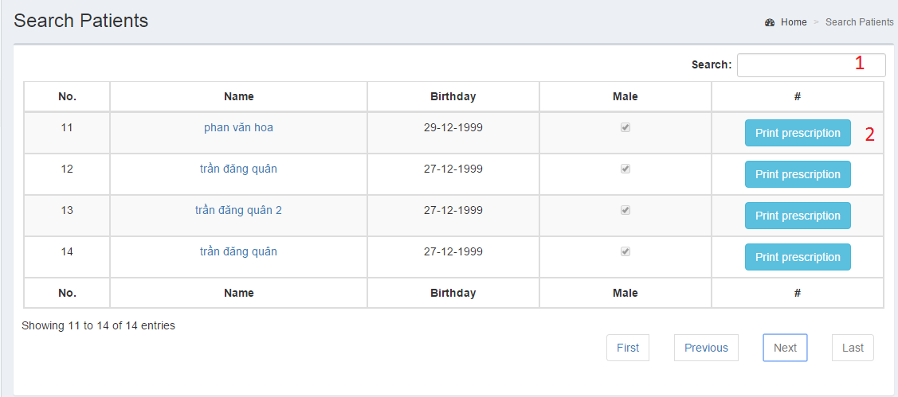

|  |  |  |  |  |  |  |  |
| --- | --- | --- | --- | --- | --- | --- | --- |
| No | Field Name | Description | Read Only | Mandatory | Control Type | Data Type | Length |
| 1 | Search patient | Search patient | No | No | N/A | N/A | N/A |

|  |  |  |  |  |
| --- | --- | --- | --- | --- |
| No | Function | Description | Validation | Outcome |
| 2 | btnPrintPrescription | Print prescription for patient | N/A | Go to print prescription page |

1. <Nurse> Print prescription output design

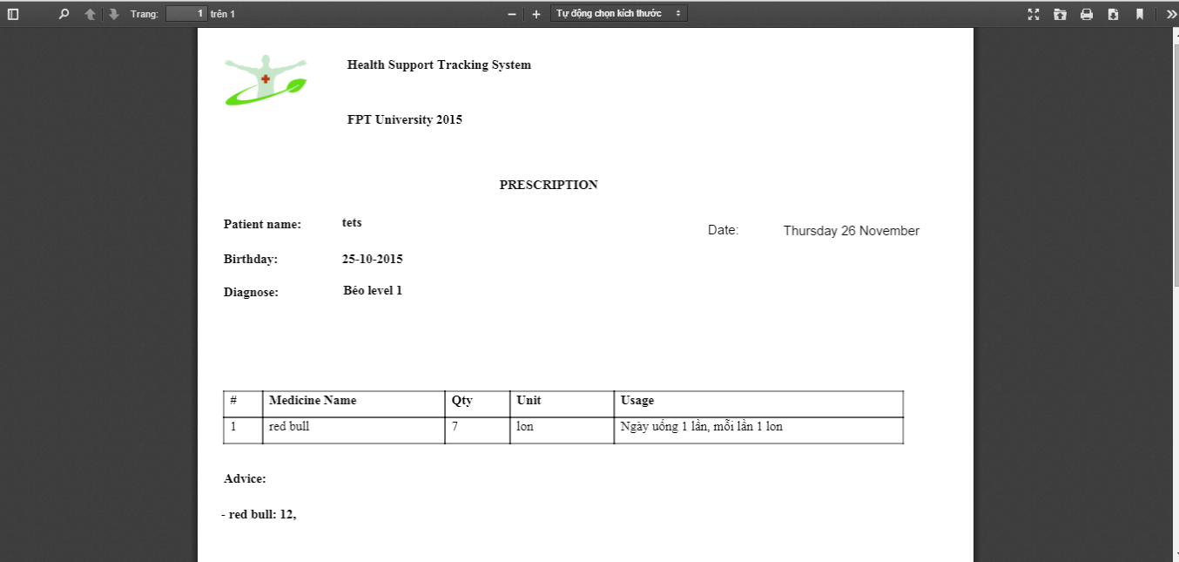

1. <Doctor Manager> Regimen management

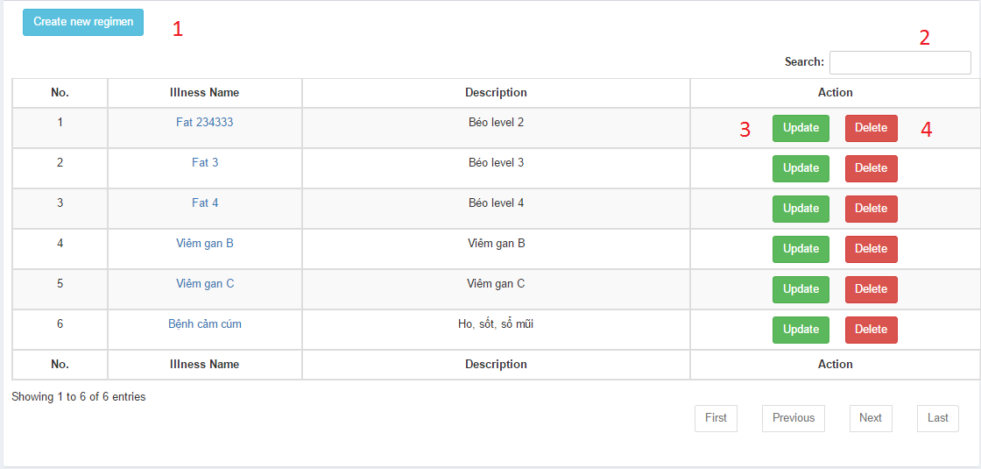

|  |  |  |  |  |  |  |  |
| --- | --- | --- | --- | --- | --- | --- | --- |
| No | Field Name | Description | Read Only | Mandatory | Control Type | Data Type | Length |
| 2 | Search regimen | Search regimen | No | No | N/A | N/A | N/A |

|  |  |  |  |  |
| --- | --- | --- | --- | --- |
| No | Function | Description | Validation | Outcome |
| 1 | btnCreate | Create new regimen | N/A | Show create new regimen pop-up |
| 3 | btnUpdate | Update regimen | N/A | Show update regimen pop-up |
| 4 | btnDelete | Delete regimen | N/A | Show delete regimen pop-up |

1. <Doctor Manager> Create regimen

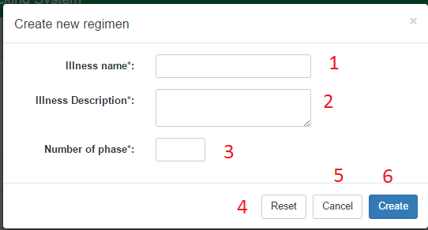

1. <Doctor Manager> Update regimen

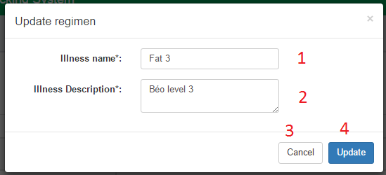

1. <Doctor Manager> Delete regimen

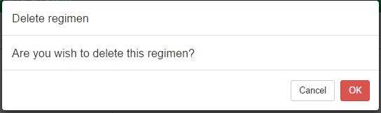

1. <Doctor Manager> Detail regimen

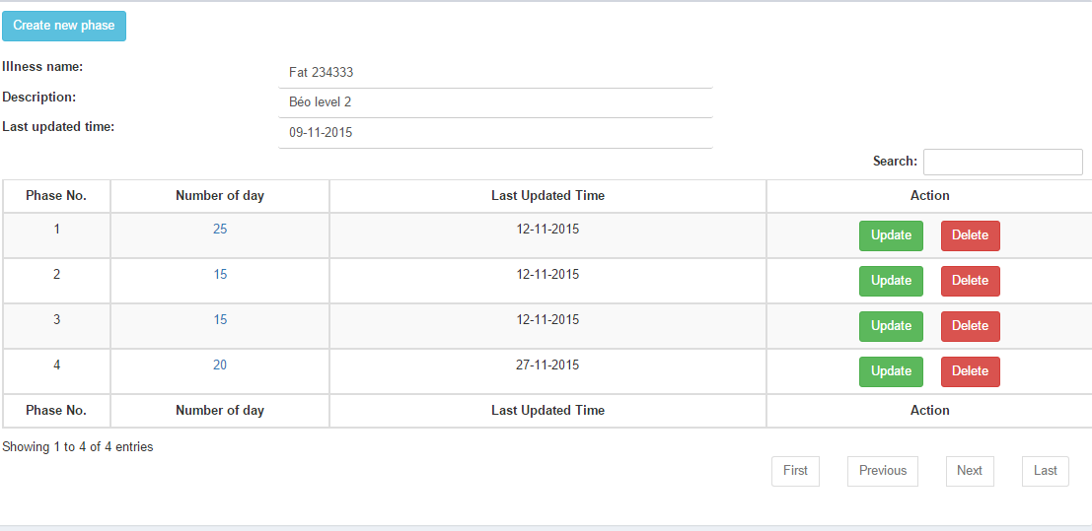

1. <Doctor Manager> Detail phase

